A B C
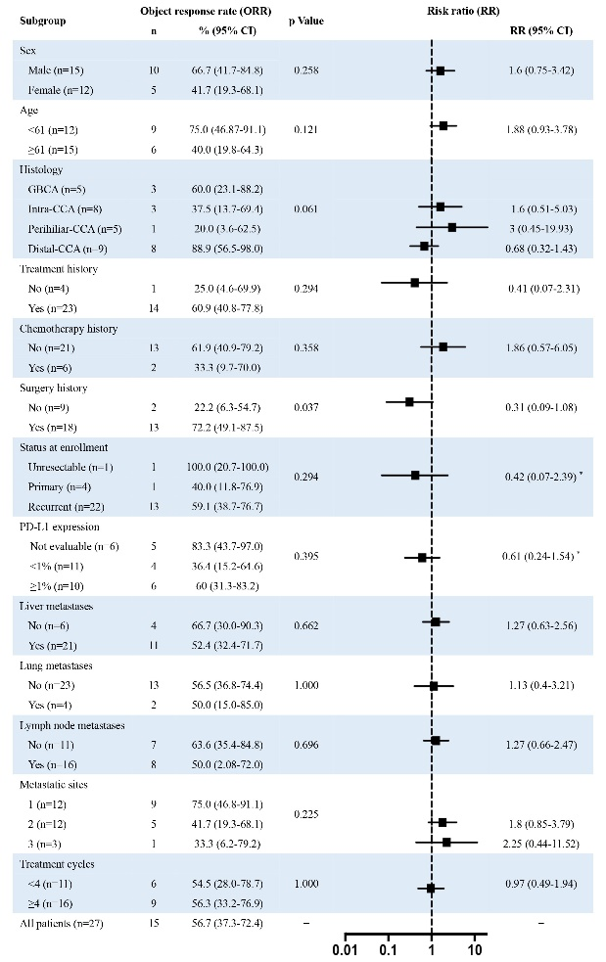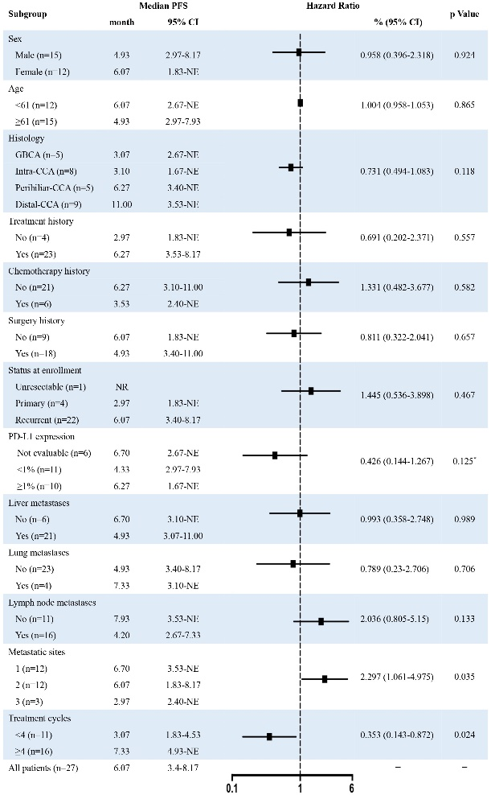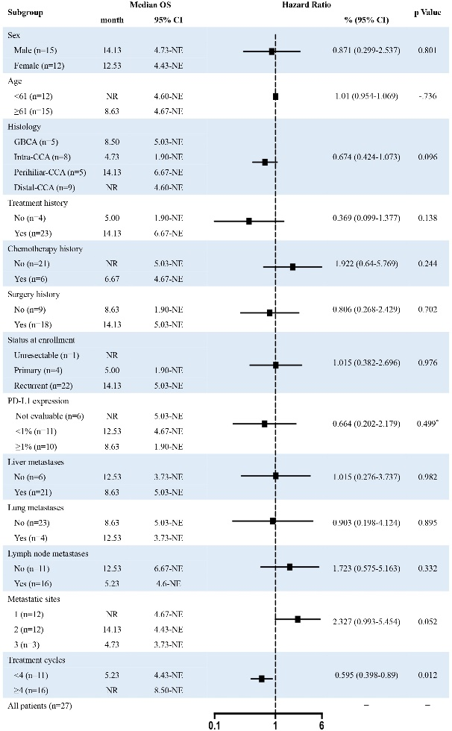
Figure S1: Multivariate analysis of the correlation between different variables and ORR (A), median PFS (B) and median OS (C).

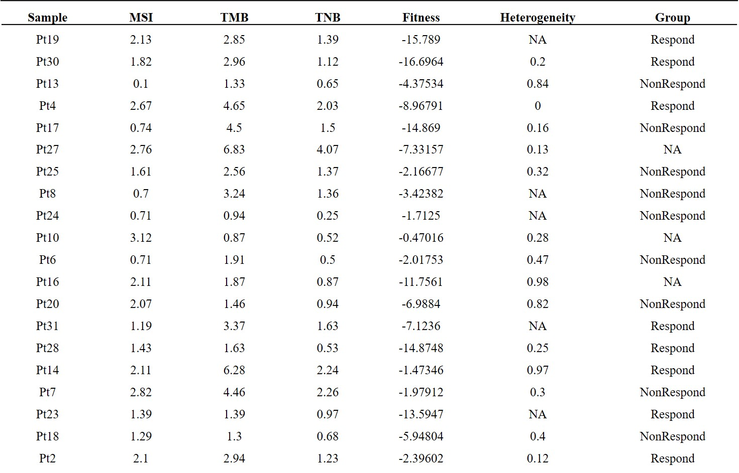
Figure S2: Data of whole-exome sequencing.

A B C
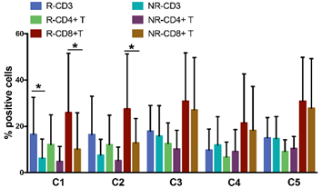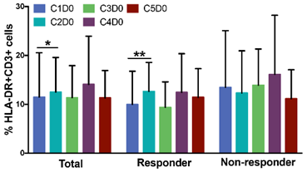
D E F
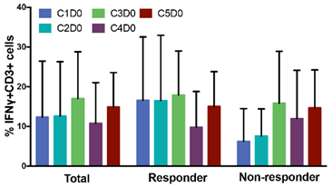
G H
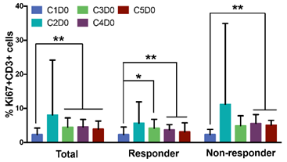
Figure S3: Analysis of the association between clinical antitumor activity and the activation of peripheral T cells.
＊: P ≤ 0.05. ＊＊: P ≤ 0.01. R = responder. NR = non-responder.
A B
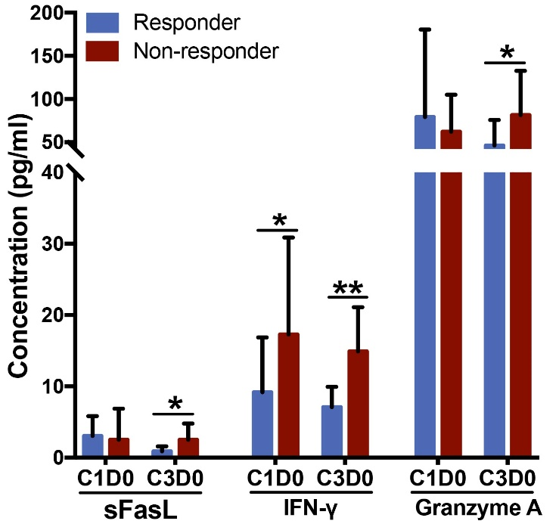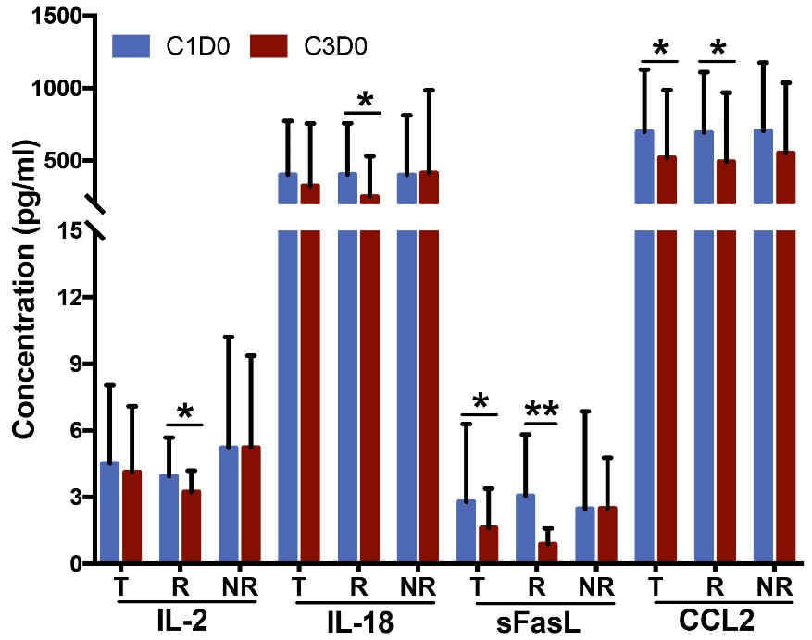
Figure S4: Analysis of the association between clinical antitumor activity and the concentration of serum cytokines and chemokines
＊: P ≤ 0.05. ＊＊: P ≤ 0.01. T = total. R = responder. NR = non-responder.

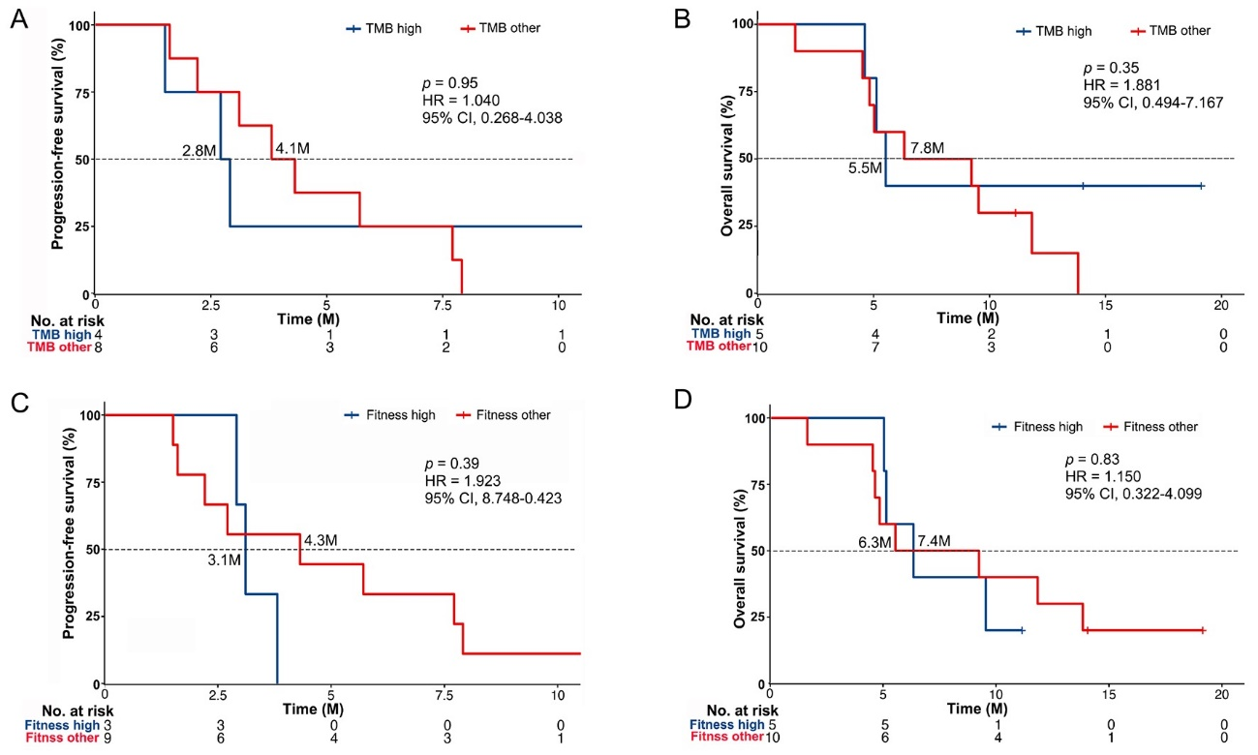
Figure S5: A. Kaplan-Meier curves of progression free survival of patients who were TMB-high versus TMB-other. B. Kaplan-Meier curves of overall survival of patients who were TMB-high versus TMB-other. C. Kaplan-Meier curves of progression free survival of patients who were fitness-high versus fitness-other. D. Kaplan-Meier curves of overall survival of patients who were fitness-high versus fitness-other.

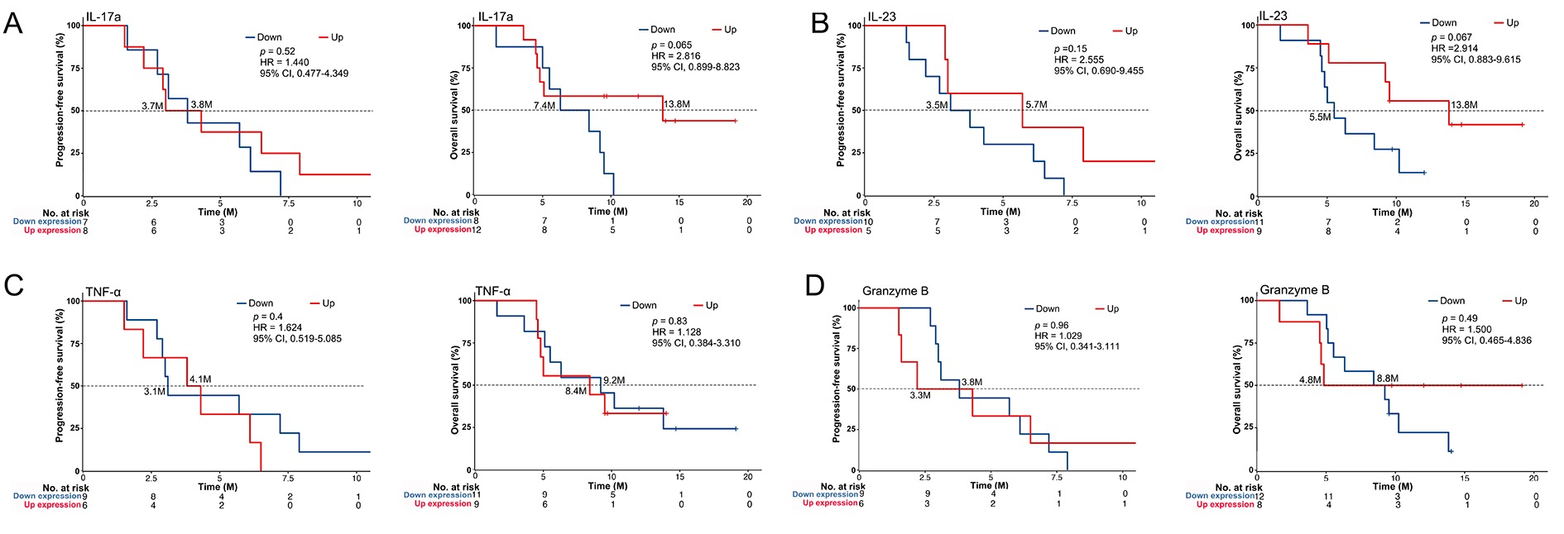
Figure S6: Analysis of correlation between serum IL-17a (A), IL-23 (B), TNF-α (C) and Granzyme B (D)and progression free survival and overall survival.

Figure S7

Patient 1 with SD Patient 2 with PR
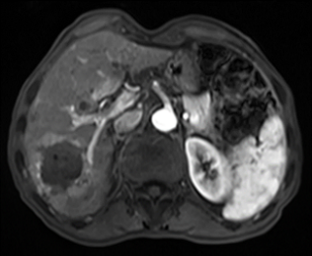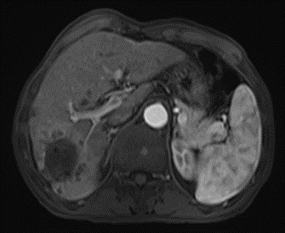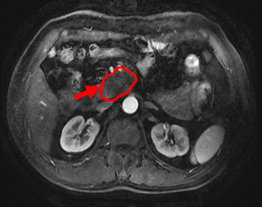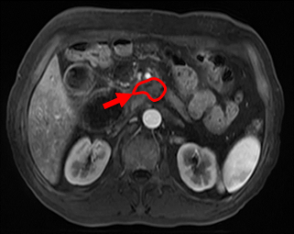
Baseline 4-cycle after treatment Baseline 2-cycle after treatment

Patient 4 with CR Patient 5 with PR
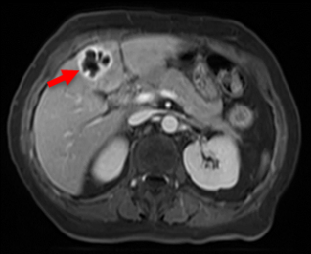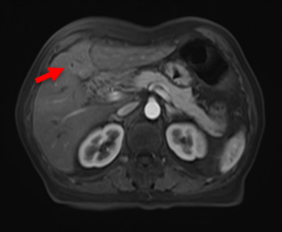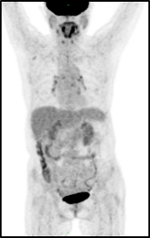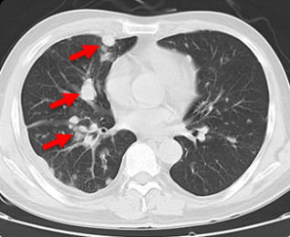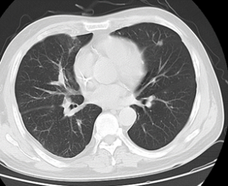
Baseline 4-cycle after treatment PET/CT confirmation Baseline 2-cycle after treatment

Patient 6 with SD Patient 7 with SD
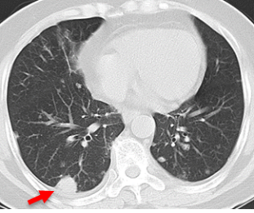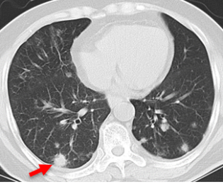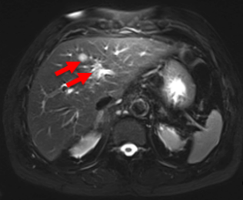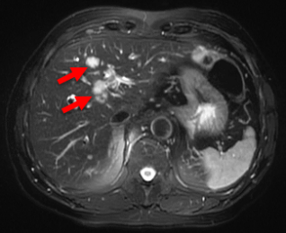
Baseline 6-cycle after treatment Baseline 4-cycle after treatment

Patient 8 with PD Patient 9 with PR
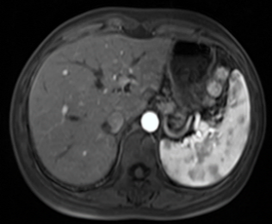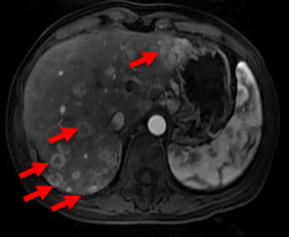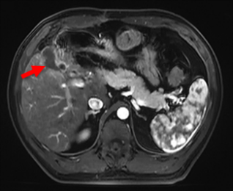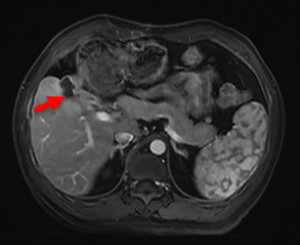
Baseline 2-cycle after treatment Baseline 2-cycle after treatment

Patient 11 with SD Patient 12 with CR
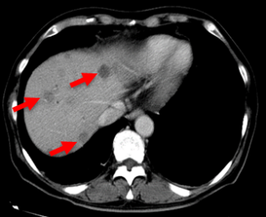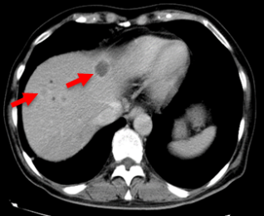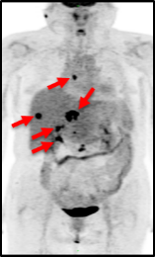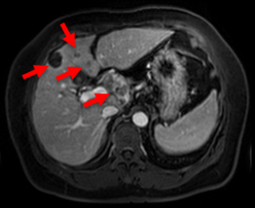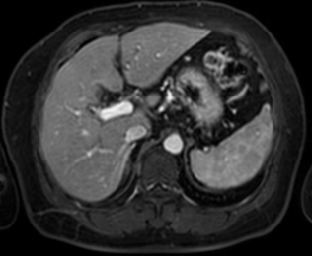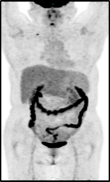
Baseline 2-cycle after treatment Baseline PET/CT Baseline 6-cycle after treatment PET/CT confirmation
Patient 13 with SD Patient 14 with CR
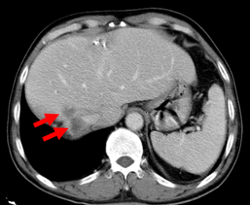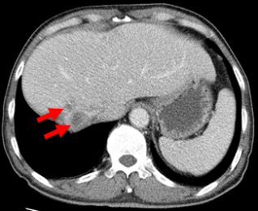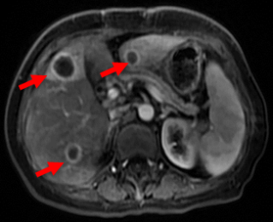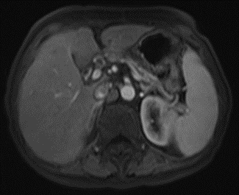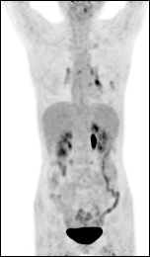
Baseline 4-cycle after treatment Baseline 6-cycle after treatment PET/CT confirmation

Patient 15 with PR Patient 17 with SD
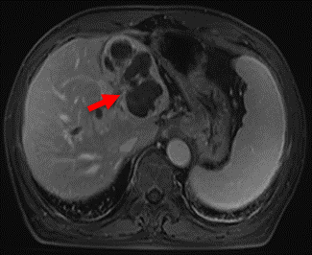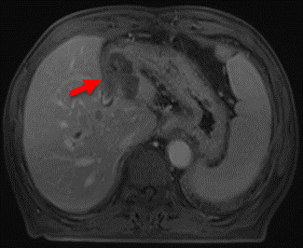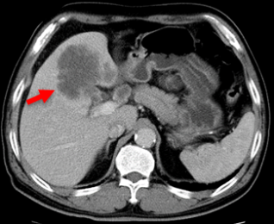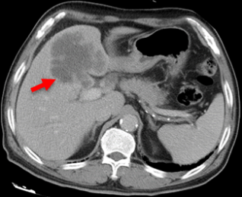
Baseline 6-cycle after treatment Baseline 2-cycle after treatment

Patient 18 with SD Patient 19 with CR
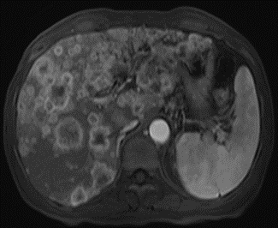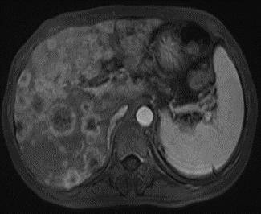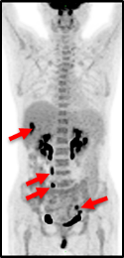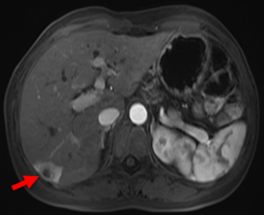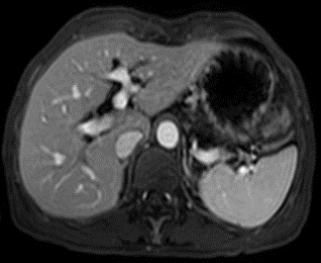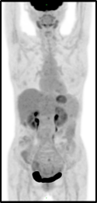
Baseline 2-cycle after treatment Baseline PET/CT Baseline 6-cycle after treatment PET/CT confirmation
Patient 20 with PD Patient 21 with SD
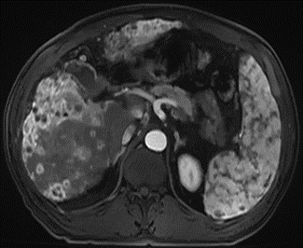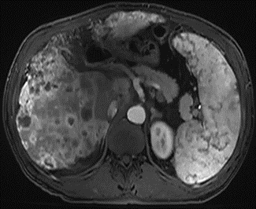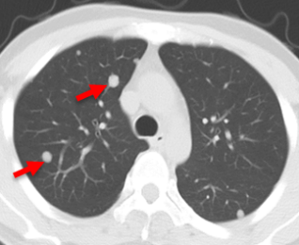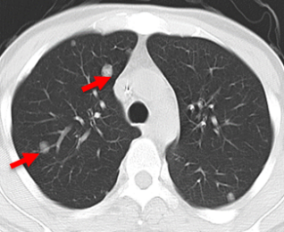
Baseline 2-cycle after treatment Baseline 6-cycle after treatment

Patient 22 with CR Patient 23 with PR
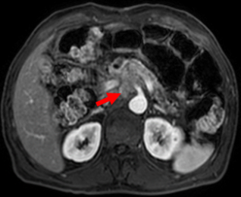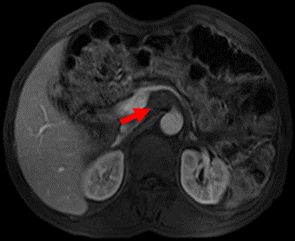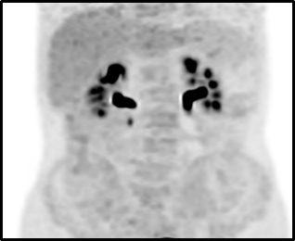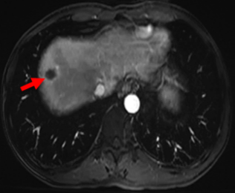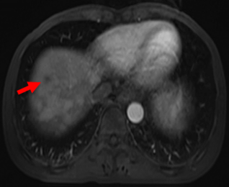
Baseline 6-cycle after treatment PET/CT confirmation Baseline 2-cycle after treatment

Patient 24 with SD Patient 25 with SD
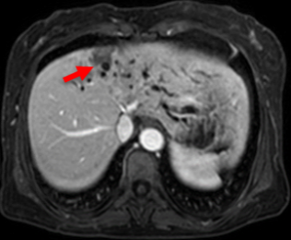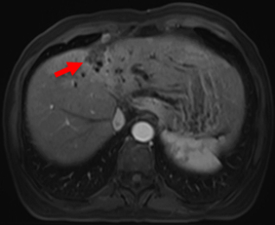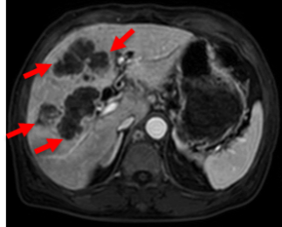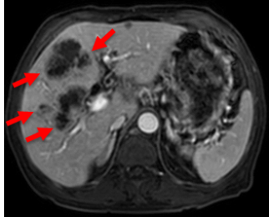
Baseline 2-cycle after treatment Baseline 2-cycle after treatment
Patient 26 with PR Patient 28 with PR
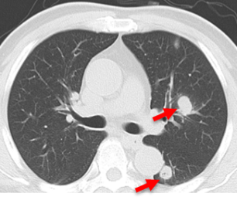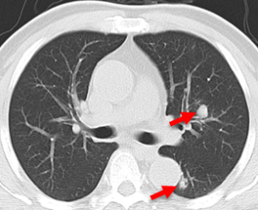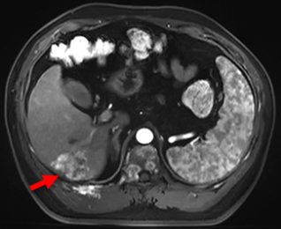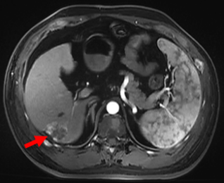
Baseline 2-cycle after treatment Baseline 2-cycle after treatment

Patient 30 with PR Patient 31 with PR
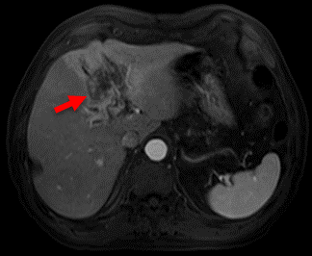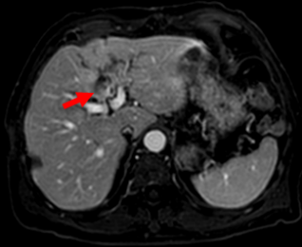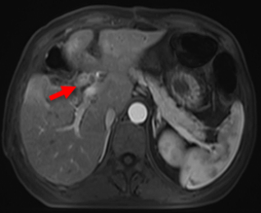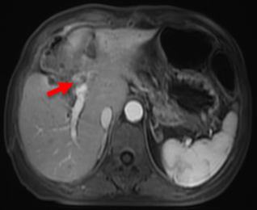
Baseline 2-cycle after treatment Baseline 2-cycle after treatment

Patient 32 with PR
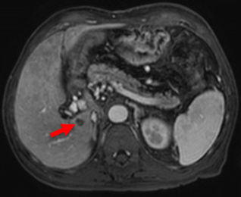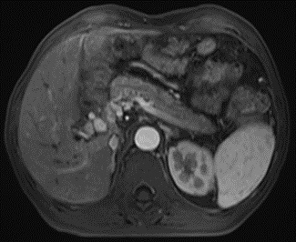
Baseline 2-cycle after treatment

